**Task 23 Q1.Created table for employees**

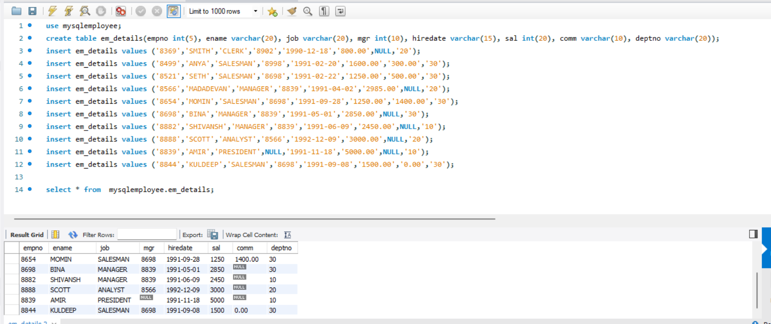

**1.Write a query to display EName and Sal of employees whose salary are greater than or equal to 2200?**

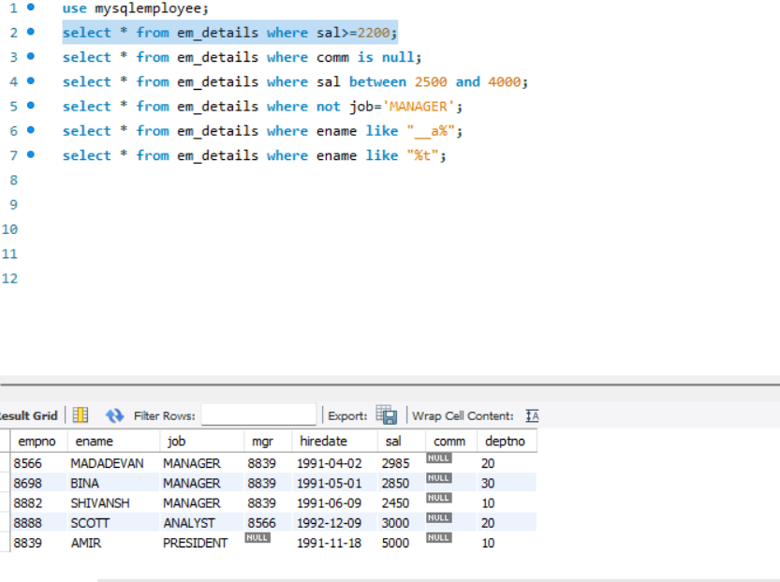

**2.Write a query to display details of employees who are not getting commission?**

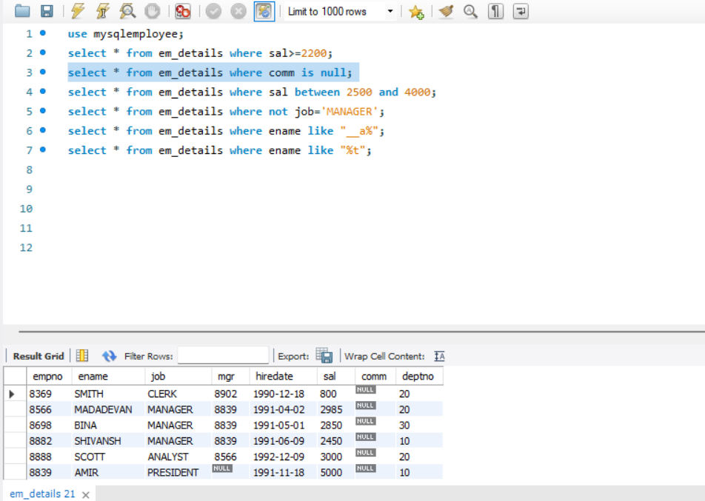

**3.Write a query to display employee name and salary of those employees who don 't have their salary in the range of 2500 to 4000?**

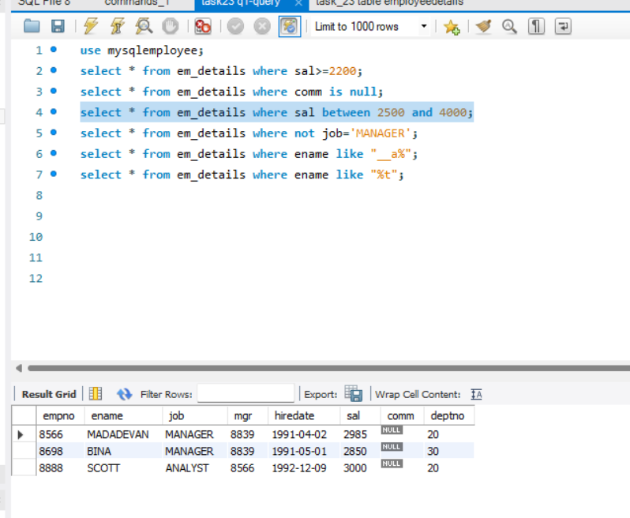

**4. Write a query to display the name, job title and salary of employees who don't have a manager?**

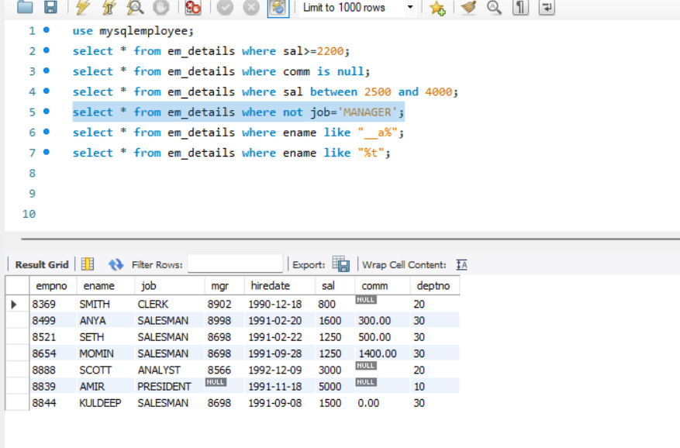

**5. Write a query to display the name of an employee whose name contains "T" as the last alphabet?**

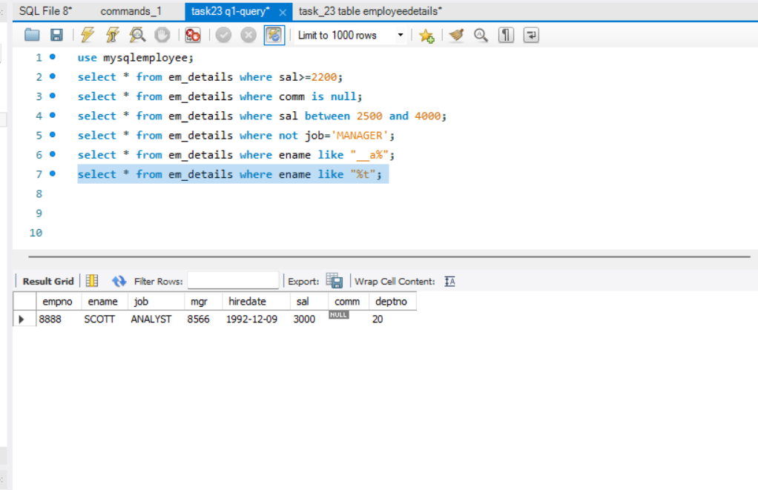

**Q2.wirte the program for JDBC Connectivity and insert the below data**



